1. ***SQL NULL Functions***

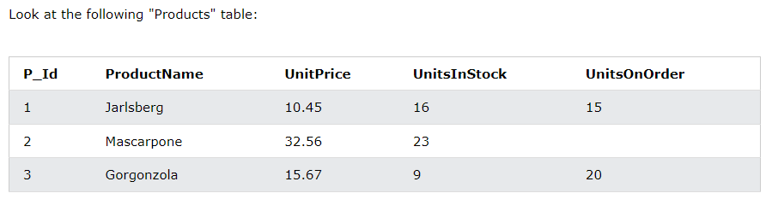

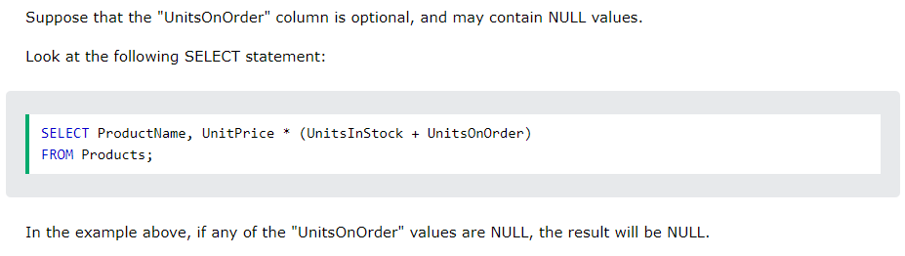

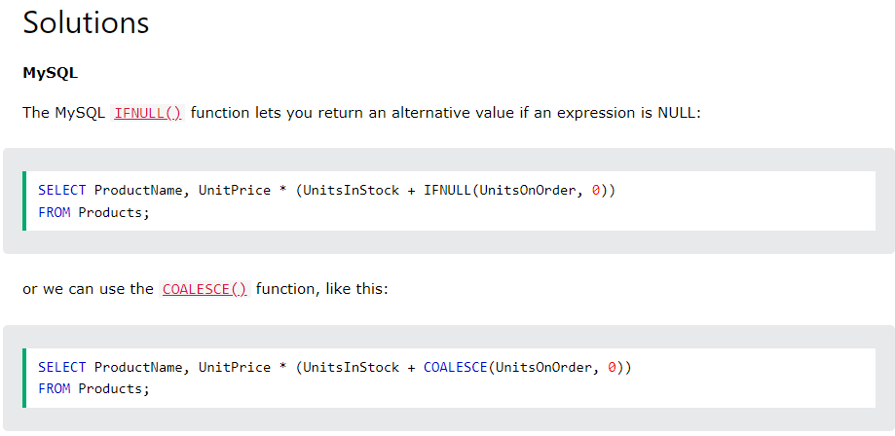

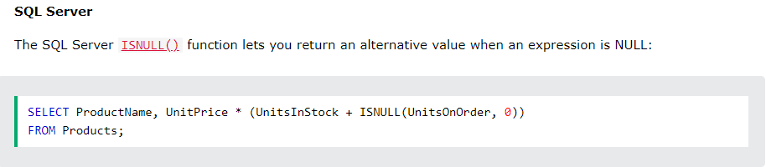

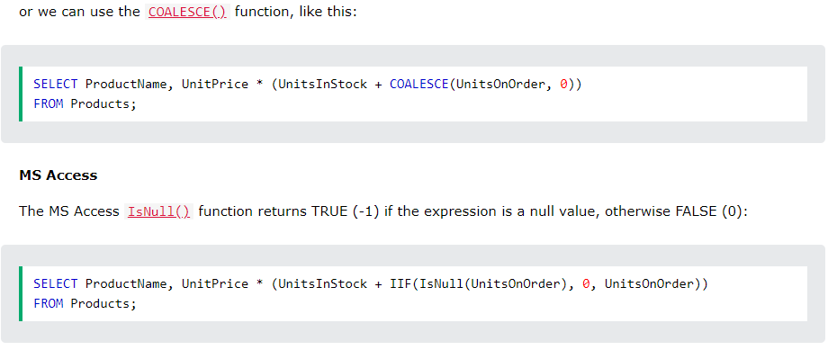

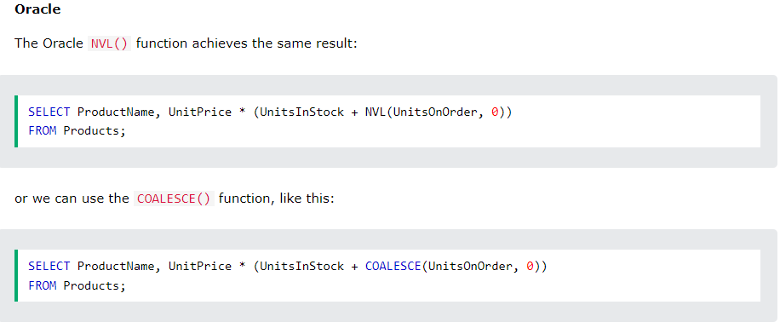

1. ***Stored Procedure***

* A stored procedure is a prepared SQL code that you can save, so the code can be reused over and over again. So if you have an SQL query that you write over and over again, save it as a stored procedure, and then just call it to execute it. You can also pass parameters to a stored procedure, so that the stored procedure can act based on the parameter value(s) that is passed.
* Stored Procedure Syntax :
* **CREATE PROCEDURE procedure_name  
  AS  
  sql_statement  
  GO;**
* Execute a Stored Procedure :
* **EXEC procedure_name;**
* Stored Procedure Example :
* Without Parameter :
  + **CREATE PROCEDURE SelectAllCustomers  
    AS  
    SELECT * FROM Customers  
    GO;**
  + **EXEC SelectAllCustomers;**
* With One Parameter :
* **CREATE PROCEDURE SelectAllCustomers @City nvarchar(30)  
  AS  
  SELECT * FROM Customers WHERE City = @City  
  GO;**
* **EXEC SelectAllCustomers @City = 'London';**
* With Muliple Parameters :
* **CREATE PROCEDURE SelectAllCustomers @City nvarchar(30), @PostalCode nvarchar(10)  
  AS  
  SELECT * FROM Customers WHERE City = @City AND PostalCode = @PostalCode  
  GO;**
* **EXEC SelectAllCustomers @City = 'London', @PostalCode = 'WA1 1DP';**

1. **SQL Operators**

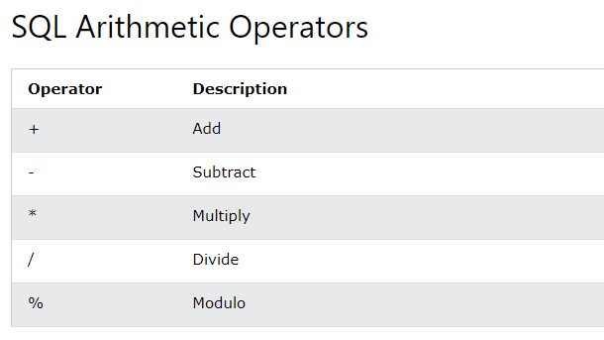

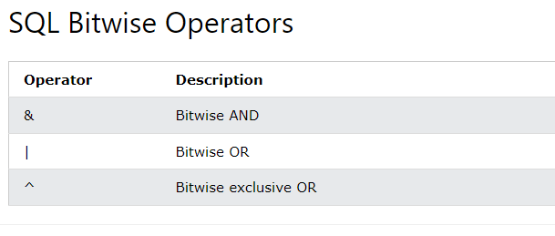

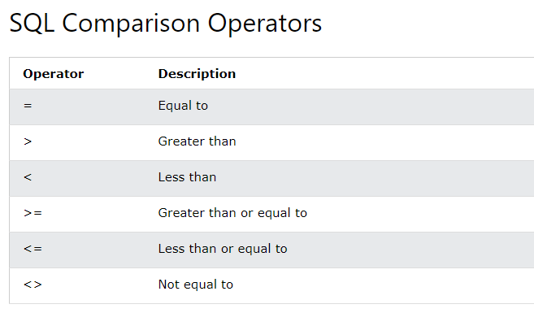

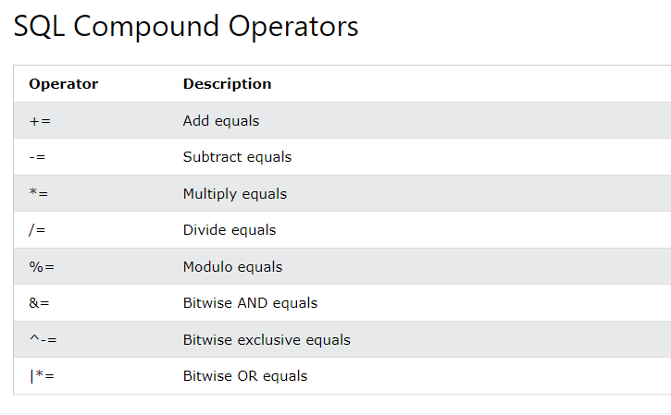

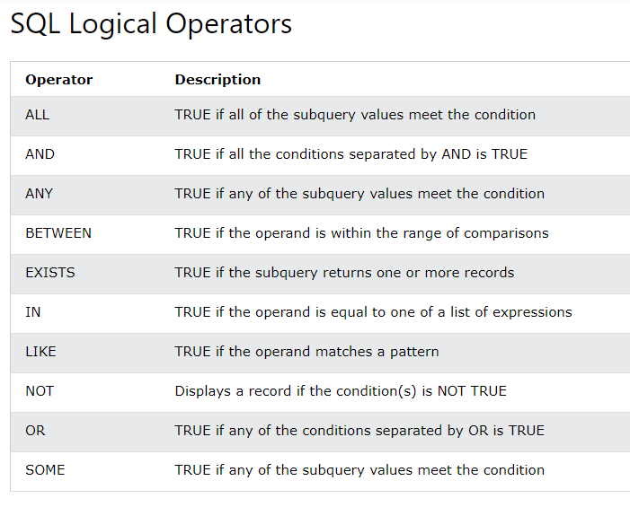

1. ***Some of The Most Important SQL Commands :***

* **SELECT** - extracts data from a database
* **UPDATE** - updates data in a database
* **DELETE** - deletes data from a database
* **INSERT INTO** - inserts new data into a database
* **CREATE DATABASE** - creates a new database
* **ALTER DATABASE** - modifies a database
* **CREATE TABLE** - creates a new table
* **ALTER TABLE** - modifies a table
* **DROP TABLE** - deletes a table
* **CREATE INDEX** - creates an index (search key)
* **DROP INDEX** - deletes an index